Tiller Infrastructure Review
  - A Framework for Assessing Long-term Options for Infrastructure at the Tiller Ranger Station

History of the Tiller Ranger Station
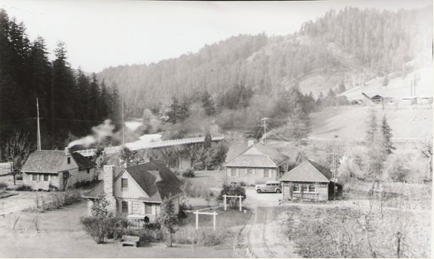
The Umpqua National Forest’s Tiller Ranger Station is located at the confluence of Elk Creek and the South Umpqua River in the small community of Tiller in Douglas County, OR. Over the years it has been the administrative headquarters for five ranger districts (Summit, Deadman, South Umpqua, Cow Creek, and Tiller). The Tiller Ranger Station is listed on the National Register of Historic Places with nine contributing buildings constructed in the rustic style by the Civilian Conservation Corps between 1935 and 1942.

Existing Condition
The Tiller Ranger Station currently serves as the administrative headquarters for the 326,000-acre Tiller Ranger District. The compound covers approximately 12 acres and includes 27 buildings, nine of which are historically important. In addition to the historical importance of the site, the Cow Creek Band of the Umpqua Tribe of Indians recognizes this site as culturally significant.
Over the years, as the structures have aged and budgets have declined, it is becoming more and more difficult to keep the up with the annual operating costs associated with the infrastructure at the Tiller Ranger Station, let alone the costs associated with the water/wastewater treatment and electrical systems, general deferred maintenance, and necessary safety remediation work.

Desired Future Condition
The Tiller Ranger District needs an administrative unit that will meet the needs of efficiently and effectively managing the Tiller Ranger District and the needs of the communities it serves. Additionally, it needs to be economically sustainable over the long-term.

Need for Change
There is a compelling need to take a hard look at the aging Tiller compound and consider the current economic and funding realities at the forest, region and national scale regarding infrastructure.

Proposal
The forest is proposing to embark on a study to evaluate the current infrastructure and the facilities needs for the Tiller Ranger District. The process will include assessment, alternative development, effects analysis, trade-off analysis to support decision-making, and a final decision. A small committee made up of the District Ranger, key district staff, the Forest Engineer, and the Forest Facilities Engineer will lead the process. Employee input and involvement will occur throughout the process. The process will be a focused effort beginning in November 2019 with objective assessments of the functional components (operational, workforce, community, and infrastructure) that will inform alternative development. The goal will be to provide a viable final recommendation in June 2020.

